MATH 3P40 - Mathematics Integrated with Computers and Applications III

Assignment 2

Matt Laidman
5199807

February 27, 2017
Problem 1
Following the procedure outlined on page 13 of the lecture notes and taking the average number of pairs of occupied cells over 100 random start configurations at each time step, the plot of the data is nearly identical to that found by P. Grassberger. A lattice size of 1x10⁵ over 2500 iterations was used.
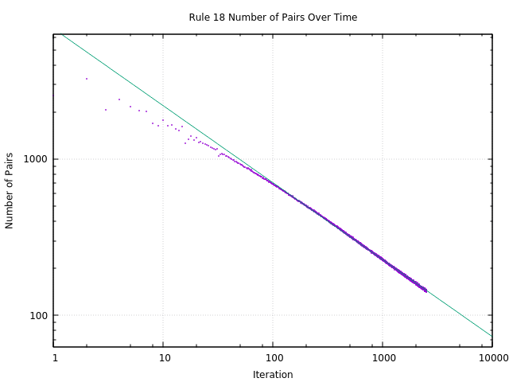
The curve fitting this data after 100 iterations is given by:
Where:
This value of m is extremely close to ½, the value found by P. Grassberger.
Problem 2
An attempt to recreate plot on page 22 of the lecture notes has been performed using a lattice size of 1000 for 1x10⁷ iterations. The average density over every 500 time steps was reported, and the values were averaged over 10 simulations. The plot of the data is similar to that found by N. Boccara et al and can be seen below.
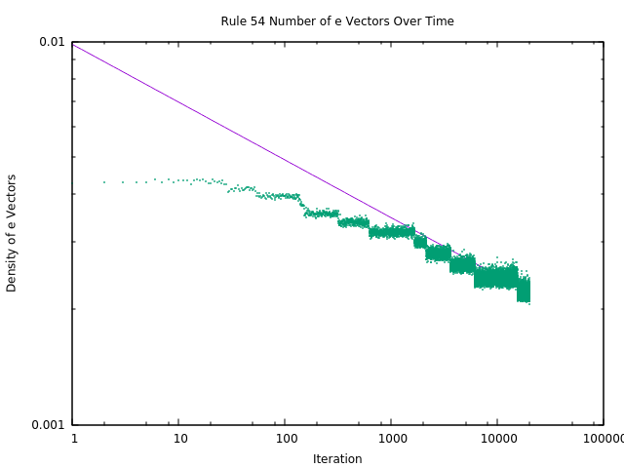
The curve fitting the data points after 7500 time steps of 500 (3750000 iterations) is given by:
Where;
This value of m is extremely close to 0.15, the value given in the paper by N. Boccara et al.
Problem 3
- Elementary cellular automaton rule 30 is defined by:
{0, 0, 0} = 0 | {0, 0, 1} = 1 | {0, 1, 0} = 1 | {0, 1, 1} = 1
{1, 0, 0} = 1 | {1, 0, 1} = 0 | {1, 1, 0} = 0 | {1, 1, 1} = 0

Which, can be written as a polynomial as:

- This rule can be visualized using gnuplot by setting the boundaries of large clusters of empty cells to a different colour, effectively highlighting them. In this image, cells which are occupied appear in both black and red. Cells which are not occupied appear in white.
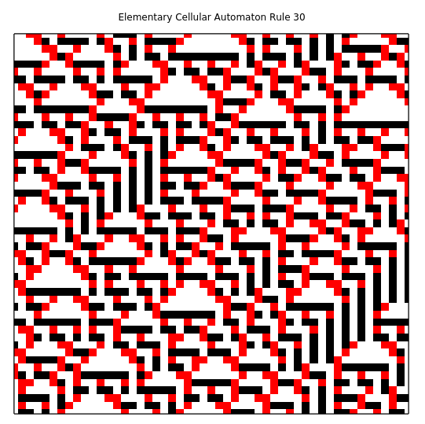
- Using a lattice size of 1x10⁵ and a starting configuration of one occupied cell, a plot of the growth of the number of occupied cells is as follows:
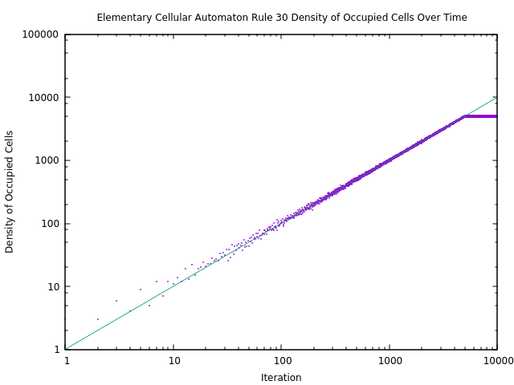

In this case, the density of the cells quickly plateaus as it approaches max capacity. If the lattice size was infinite, this plateau would not be present. As t goes to infinity, the number of occupied cells will approach infinity too.
The line fitting this data is given by:
Where;
This exponent m is very close to 1, showing that the number of cells grows at near the same rate as time. As time approaches infinity, the number of occupied cells will approach will also approach infinity if the lattice size is also infinite, or:

